

# Persona Template

Aurora Harley, User Experience specialist at the Nielsen Norman Group, explains that there are six common pieces of information that make up a persona:

* Name, age, gender, and an image of the persona, preferably including some context in the background
* A tag line, indicating what the persona does or considers relevant in his or her life
* The experience and relevant skills the persona has in the area of the product or service you will be developing
* Some context to indicate how they would interact with your product or service (e.g. the voluntariness of use, frequency of use, and preferred device)
* Any goals, attitudes, and concerns they would have when using your product or service
* Quotes or a brief scenario, which indicate the persona’s attitude toward the product or service you’re designing. If the persona already uses an existing product or service to meet his or her needs, you might describe the use of that here.

These elements can then be combined into a layout, which is the same for every persona you create in a project. As you’ll most likely develop more than one persona for a design problem, to cover the whole breadth of your user group and the diversity of characteristics in it, keeping to one layout will help you communicate the variety in personas clearly. Below is an example (followed by a template you can print and use) of what such a layout could look like.

[Continued on next page]

**INTERACTION-DESIGN.ORG**

Creative Commons BY-SA license: You are free to edit and redistribute this template, even for commercial use, as long as you give credit to the Interaction Design Foundation. Also, if you remix, transform, or build upon this template, you must distribute it under the same CC BY-SA license.

[Continued from previous page]



|  |  |
| --- | --- |
| *Insert a photo of your persona here* | Name  *Suparman Prakoso* |
| Age  *26 years* |
| Psyche  *Extrovert* |
| Background  Prakoso is a 26 years old engineering intern in a start-up.He loves travelling and | *What is the occupation of your persona? Describe their main responsibilities and issues at work.*  *What is their education level and familiarity with technology?*  *What are their roles, other than work (e.g. mom, caregiver, volunteer), and what responsibilities do they bring?* |
| Emotions and attitudes | *What is the persona’s attitude towards technology, the company, the information?* |
| Personal traits | *Describe any personal traits that might impact on your project, e.g., is the person a fast and keen learner, do they embrace or resist change, are they enthusiastic, would they make a good ambassador for your solution?* |
| Needs | *What are the needs of this persona that could be addressed by your project? Why do they arise? Do these needs come into conflict with requirements arising from the persona’s other roles?* |
| Situations | *What are the situations this persona ﬁnds themselves in, with respect to their needs? Give an account of these situations, for example, by describing the way this person currently addresses their needs, or giving an account of how they go about their business during the day.* |
| Scenarios | *Create some scenarios that show how the person manages to solve their needs in a new way, using your product. The scenario should have a beginning (presents the user and what the persona wants to achieve), middle (what the user does with your product and the persona’s motivation for pursuing the goal) and end (describes whether the persona succeeds in his or her intentions).* |

[Continued on next page]

**INTERACTION-DESIGN.ORG**

Creative Commons BY-SA license: You are free to edit and redistribute this template, even for commercial use, as long as you give credit to the Interaction Design Foundation. Also, if you remix, transform, or build upon this template, you must distribute it under the same CC BY-SA license.

### Music is essential to Rebecca’s life. She is listening to tunes almost every second of her life, particularly while working.



**Rebecca**

Casual audiophile

Age 26

Gender Female

Occupation Frontend developer

Marital status Single

Location Mountain View

Online locations

Computer(s) Internet usage

Work and mobile

iPhone and MacBook Pro 8-9 hours

TECHNOPHOBE

TECH WIZ

CDs

MUSIC STREAMING

CASUAL LISTENER

HARDCORE GEEK

Obstacles Rebecca faces:

* + Too busy to explore new music artists she might like
  + Streaming music consumes a lot of data

### Rebecca’s situation

Goals, motivations:

* Listen to great music to keep her productive at work
* Relax and unwind at the end of the day
* Superior music quality for full enjoyment of tracks
* Expand the circle of music artists she listens to

### How will Rebecca interact with Spotify?

Questions Rebecca will ask:

* + How do I keep updated on new releases by artists I follow?
  + How do I learn of new artists I haven’t heard of?
  + Can I listen to music in a data-efﬁcient manner?
  + How can I listen on both my MacBook and my iPhone?

### Who influences Rebecca?

Key words

music, jazz, r&b, pop, artists, new releases, top charts, background music

### Rebecca’s story

Music is a big part of my life; I like to think that I always have a “background music” running in each scene of my life. I love working while listening to music; somehow, it gives me a lot of focus on my task.

I regularly talk to my co-workers about music and singers — that’s what we like to talk about over lunch. We’re constantly looking for new artists to inspire us and to expand our music library, but lately it seems a little tough to do that. Everything seems to have a “ﬁlter bubble” effect, and we keep listening to the same genres and artists.

Ads

Music charts

Her own tastes

Friends

Co- workers

I really enjoy ﬁnding new artists that match my subjective taste, and most of the times I get those from my close friends. I wish there were a way to ﬁnd more music and artists without having to rely on the serendipity of life!

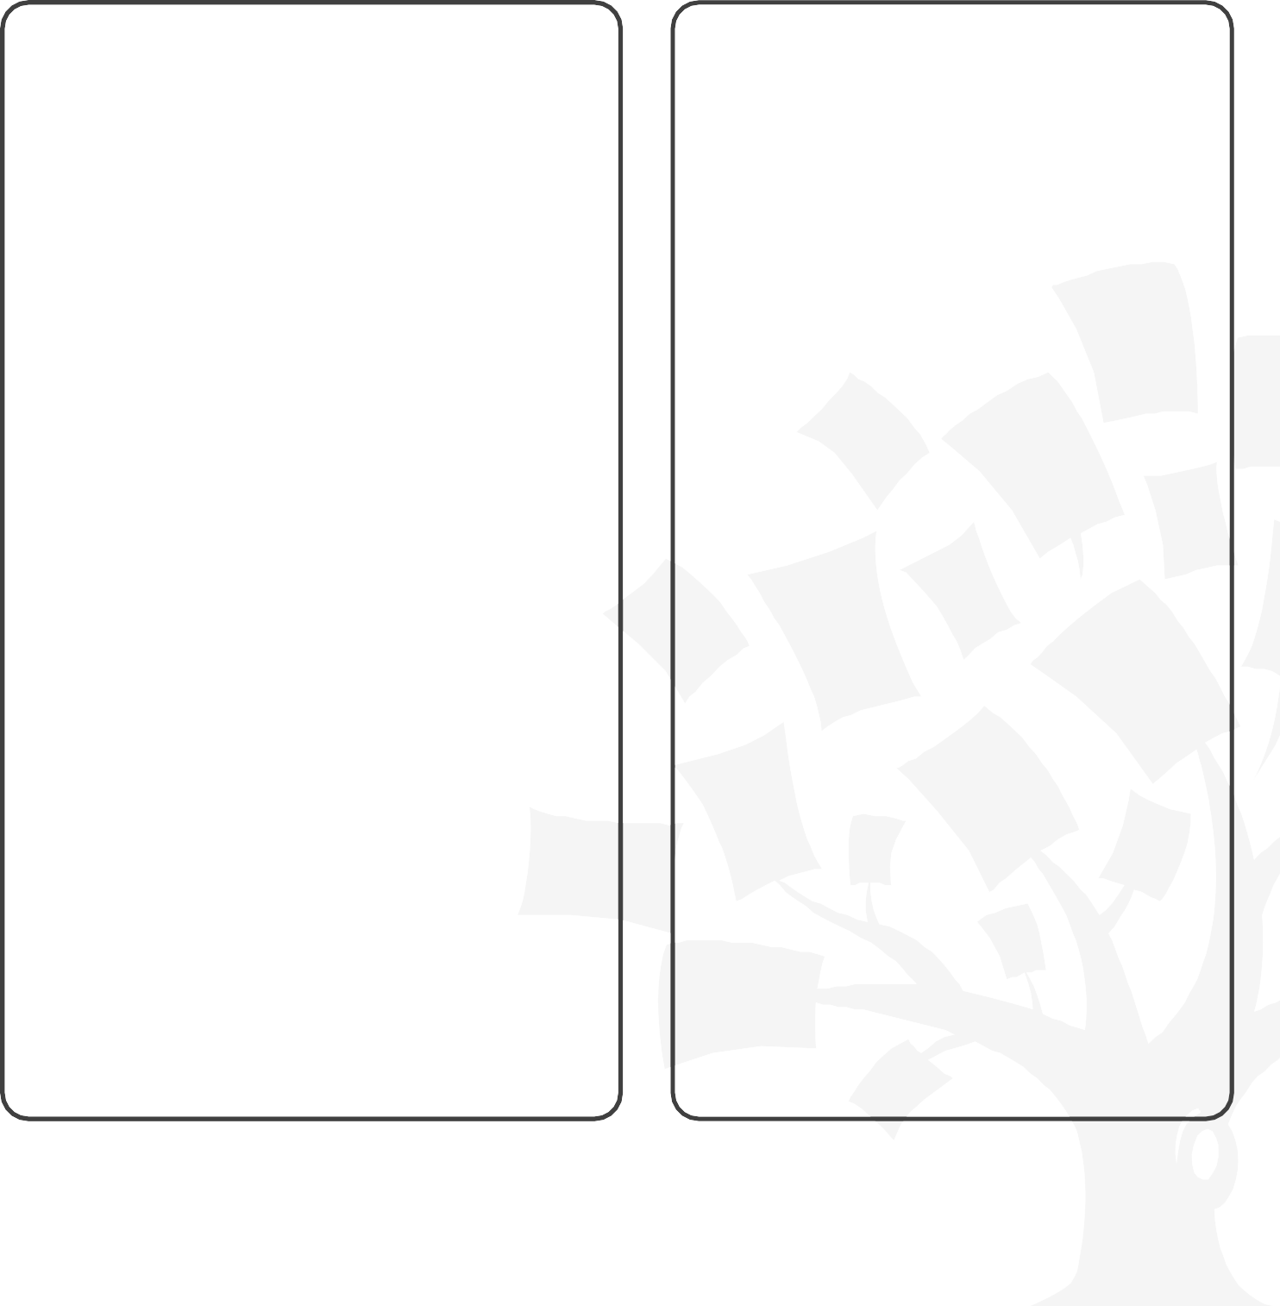

Example of a persona that shows the six main elements you should include. Name, age, gender, tag line, experience and skills are placed on the left-hand side. The middle column focuses on the context to indicate how they would interact with a product or service. Finally, on the right-hand side some goals and concerns are shared, as well as a short scenario to indicate the persona’s attitude.

**INTERACTION-DESIGN.ORG**

Creative Commons BY-SA license: You are free to edit and redistribute this template, even for commercial use, as long as you give credit to the Interaction Design Foundation. Also, if you remix, transform, or build upon this template, you must distribute it under the same CC BY-SA license.

**Persona Template**



|  |  |
| --- | --- |
| *Insert a photo of your persona here* | Name |
| Age |
| Psyche |
| Background |  |
| Emotions and attitudes |  |
| Personal traits |  |
| Needs |  |
| Situations |  |
| Scenarios |  |

**INTERACTION-DESIGN.ORG**

Creative Commons BY-SA license: You are free to edit and redistribute this template, even for commercial use, as long as you give credit to the Interaction Design Foundation. Also, if you remix, transform, or build upon this template, you must distribute it under the same CC BY-SA license.

Context and obstacles faced:

Situation: Goals, motivations, keywords

*Insert a photo of your persona here*

### Name:

How will he/she interact with your product/service?

Age: Gender: Occupation: Marital status:

Location:

***Other traits:***

Questions he/she will ask:

Influences:

Story

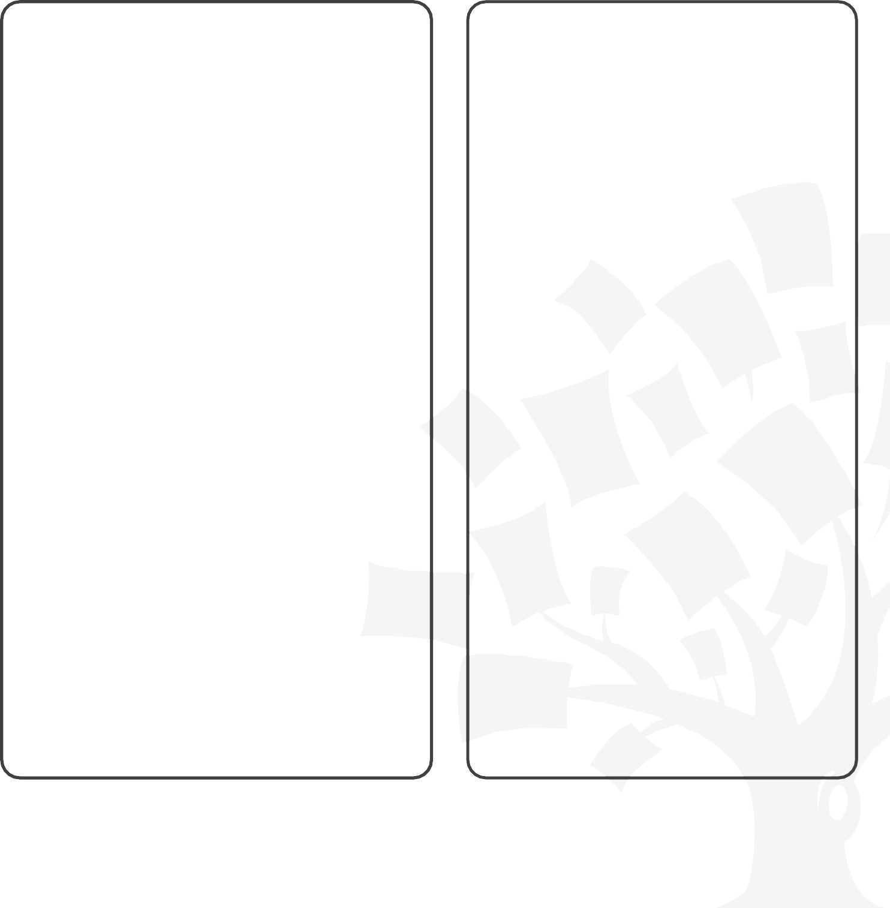

Template of a persona that shows the six main elements you should include. Name, age, gender, tag line, experience and skills are placed on the left-hand side. The middle column focuses on the context to indicate how they would interact with a product or service. Finally, on the right-hand side some goals and concerns are shared, as well as a short scenario to indicate the persona’s attitude.

**INTERACTION-DESIGN.ORG**

Creative Commons BY-SA license: You are free to edit and redistribute this template, even for commercial use, as long as you give credit to the Interaction Design Foundation. Also, if you remix, transform, or build upon this template, you must distribute it under the same CC BY-SA license.

# Do you want to learn more?



Learn how to use this template to your best advantage in our online course [Become a UX Designer](https://www.interaction-design.org/courses/become-a-ux-designer-from-scratch?utm_source=template&utm_medium=learn-more) [from Scratch](https://www.interaction-design.org/courses/become-a-ux-designer-from-scratch?utm_source=template&utm_medium=learn-more). Sign up for it today and take your step towards your dream UX job if you haven’t already started the course.

## [Become a UX Designer from Scratch](https://www.interaction-design.org/courses/become-a-ux-designer-from-scratch?utm_source=template&utm_medium=learn-more)

### Beginner course

If you want to join one of the most rapidly growing ﬁelds in design, then look no further—[Become a](https://www.interaction-design.org/courses/become-a-ux-designer-from-scratch?utm_source=template&utm_medium=learn-more) [UX Designer from Scratch](https://www.interaction-design.org/courses/become-a-ux-designer-from-scratch?utm_source=template&utm_medium=learn-more) is the course for you. You’ll learn the skills required to assist companies in delivering the right UX for their products through being taught tried-and-tested, industry standard techniques. You’ll also discover how to create various UX deliverables with the help of downloadable templates like this one. From customer journey maps to paper prototypes, this course will show you how to make use of such templates when creating your UX portfolio—something that will truly make an impact on your UX job applications. What’s more, you’ll gain access to video interviews with senior UX hirers and experts from companies such as Google and SAP—providing you insight into what skills and attributes will give you an advantage over fellow candidates during the UX hiring process. Wait no longer to kick-start your professional UX career!

[Learn more about this course >](https://www.interaction-design.org/courses/become-a-ux-designer-from-scratch?utm_source=template&utm_medium=learn-more)

**INTERACTION-DESIGN.ORG**

Creative Commons BY-SA license: You are free to edit and redistribute this template, even for commercial use, as long as you give credit to the Interaction Design Foundation. Also, if you remix, transform, or build upon this template, you must distribute it under the same CC BY-SA license.

# How to advance your career with our online courses

Take online courses by Get a Course Certiﬁcate. Advance your career.

industry experts.

Lessons are self-paced so you'll never be late for class or miss a deadline.

Your answers are graded by experts, not machines. Get an industry-recognized Course Certiﬁcate to prove your skills.

Use your new skills in your existing job or to get a new job in UX design. Get help from our community.

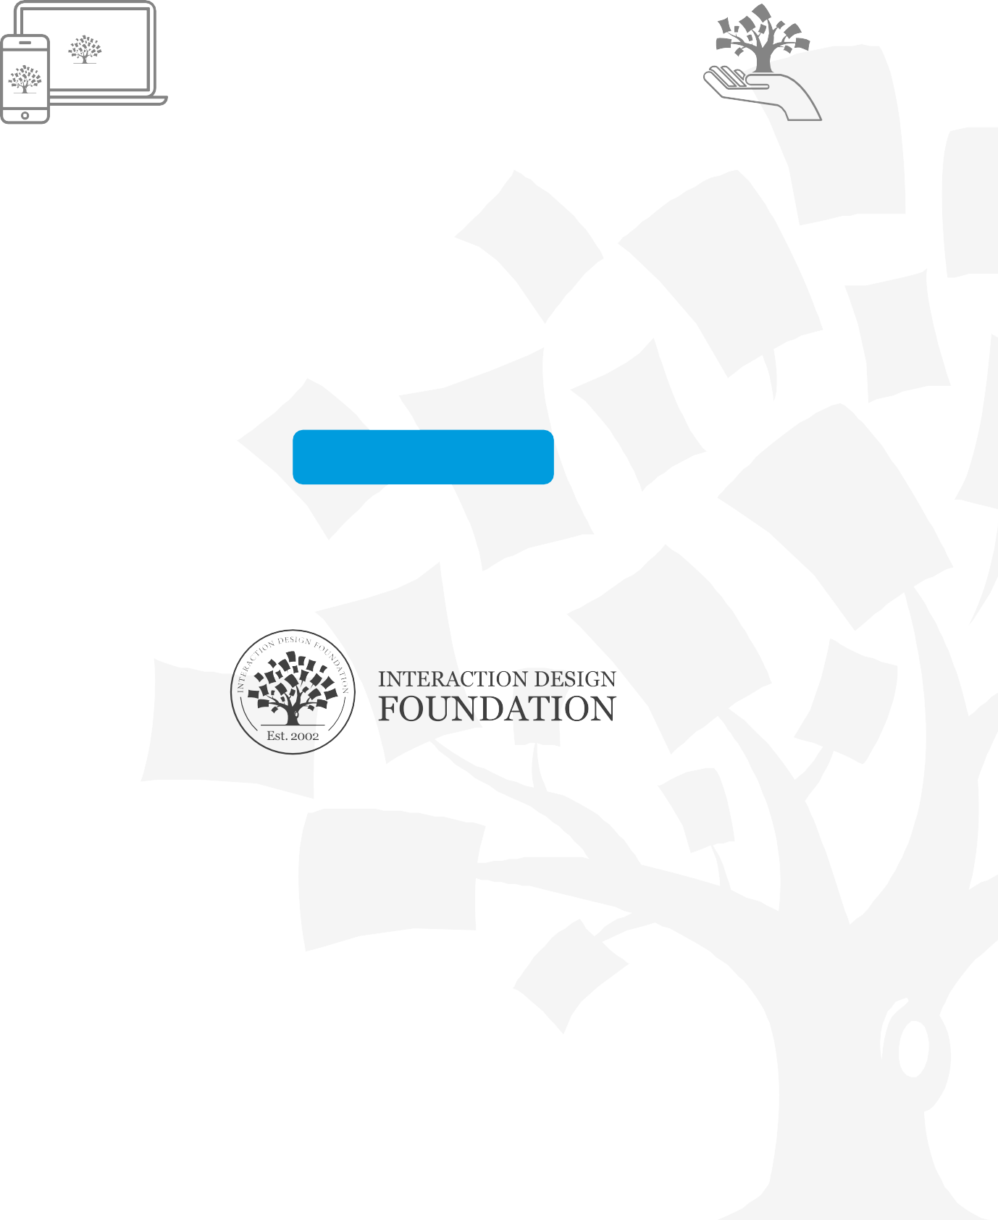

[See all our courses >](https://www.interaction-design.org/courses?utm_source=template)

## About the Interaction Design Foundation

With over 66,000 alumni, the Interaction Design Foundation is the biggest design school globally. Industry leaders such as IBM and Adobe train their teams with our courses, and universities such as MIT and the University of Cambridge include our courses in their curricula. Our online courses are taught by industry experts and cover the entire spectrum of UX design from beginner to advanced. We give you industry-recognized course certiﬁcates to advance your career. Since 2002, we’ve put together the world’s biggest and most authoritative library of open-source UX Design literature created by such noted authors as Don Norman and Clayton Christensen.

**INTERACTION-DESIGN.ORG**

Creative Commons BY-SA license: You are free to edit and redistribute this template, even for commercial use, as long as you give credit to the Interaction Design Foundation. Also, if you remix,

transform, or build upon this template, you must distribute it under the same CC BY-SA license.